**Develop a Python script**

|  |  |
| --- | --- |
| Team ID | PNT2022TMID13652 |
| Project Name | SMART WASTE MANAGEMENT SYSTEM FOR METROPOLITAN CITIES |
| Maximum Marks | 4 Marks |

SMART WASTE MANAGEMENT SYSTEM FOR METROPOLITIAN CITIES

Create a code snippet using python to

1. Extract weather data from Open Weather Map using APIs
2. Send the extracted data to the cloud
3. Receive data from the cloud and view it in the python compiler

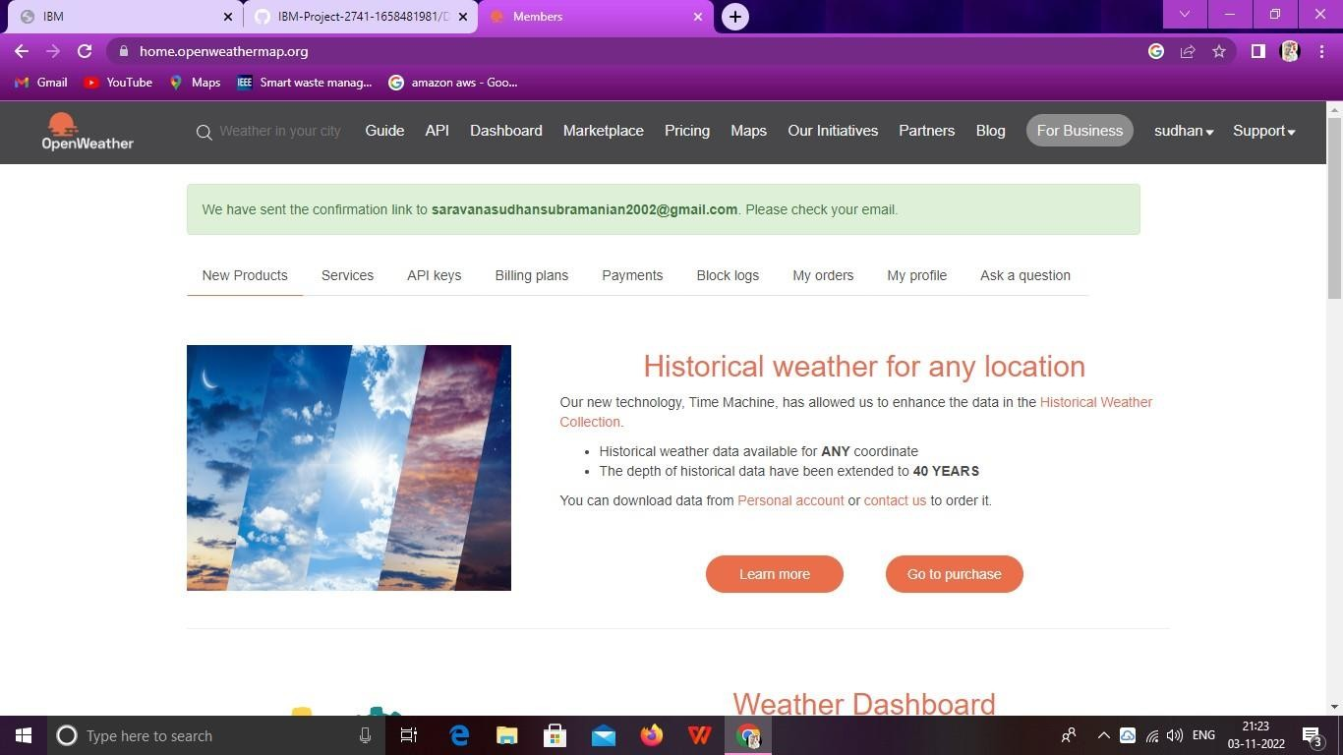

**OUTPUT:**

